**Installing MySQL Server**

1. Go the link : <https://downloads.mysql.com/archives/installer/>
2. Select the 8.0.20 as Product version
3. Click on the MSI installer option to download

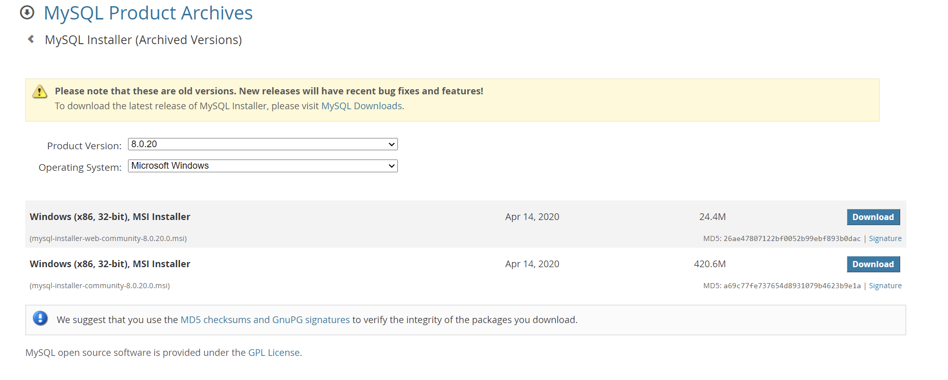

1. The file should get automatically downloaded. Once the download is complete, click on the downloaded file to open it and click on the **Run** option

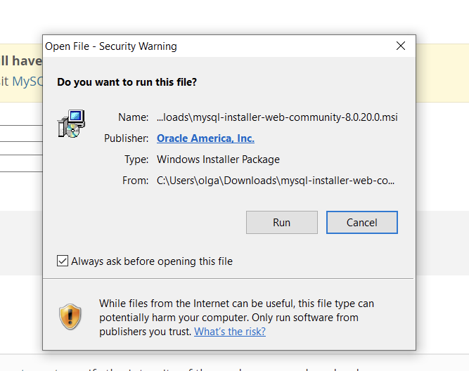

After clicking on run the MYSQL installer will start

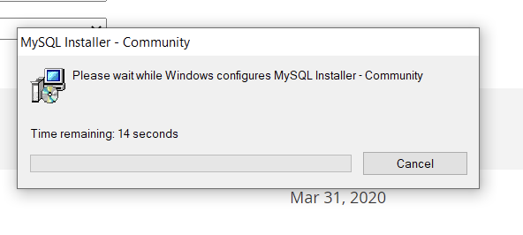

Click **NO** if any upgrade pop up comes in

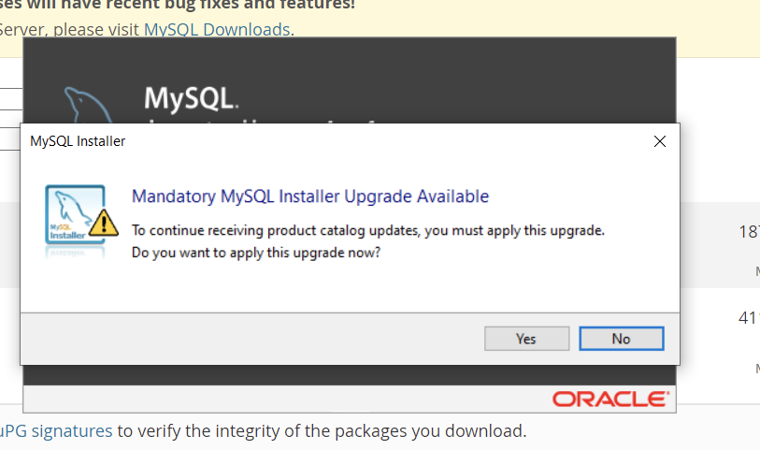

1. MySQL installer will open and you can keep on clicking on **Next** with the default settings

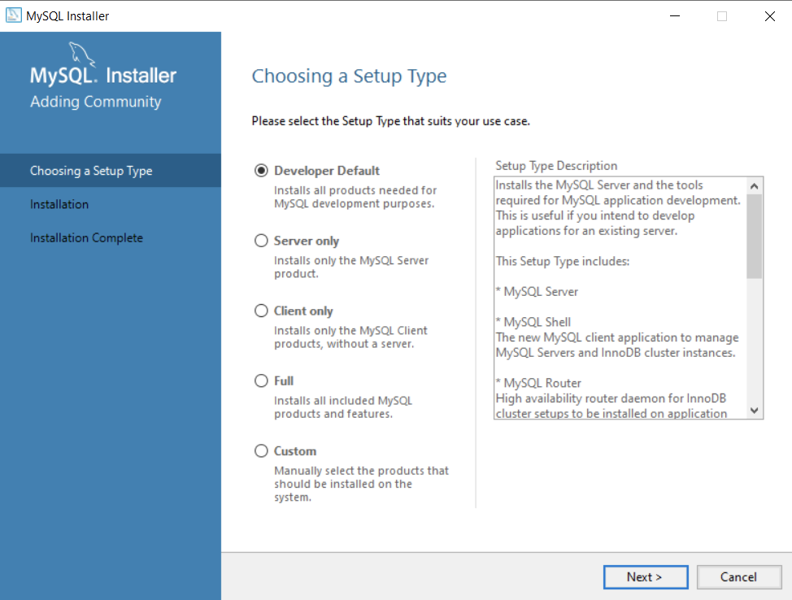

You don’t need these requirements so stick to the default settings and don’t select them. Click on **Next**

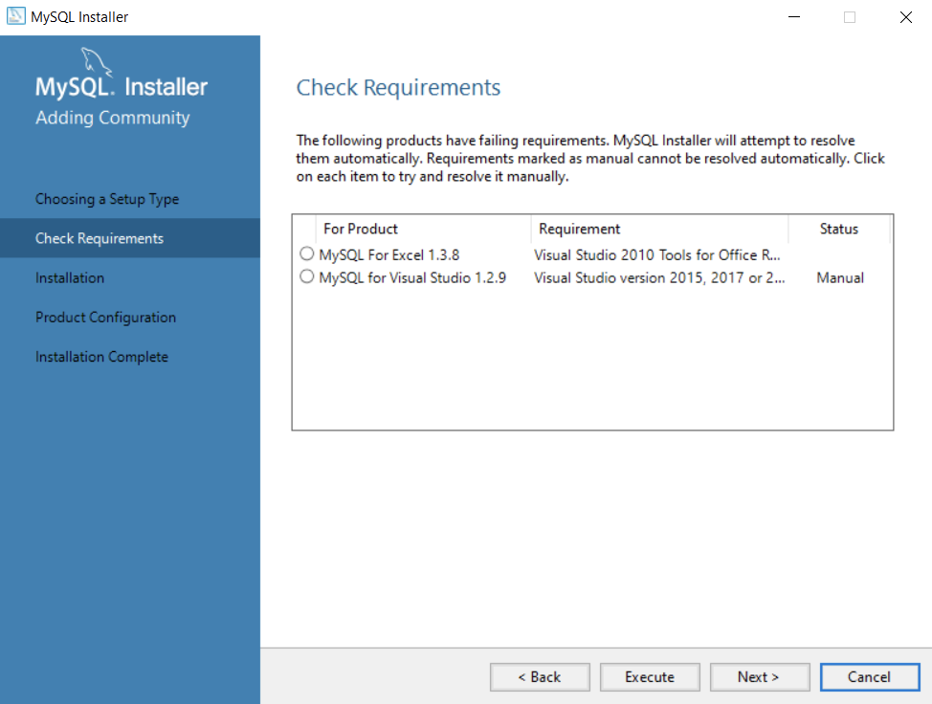

Click on **Execute** and it’ll install all the necessary files.

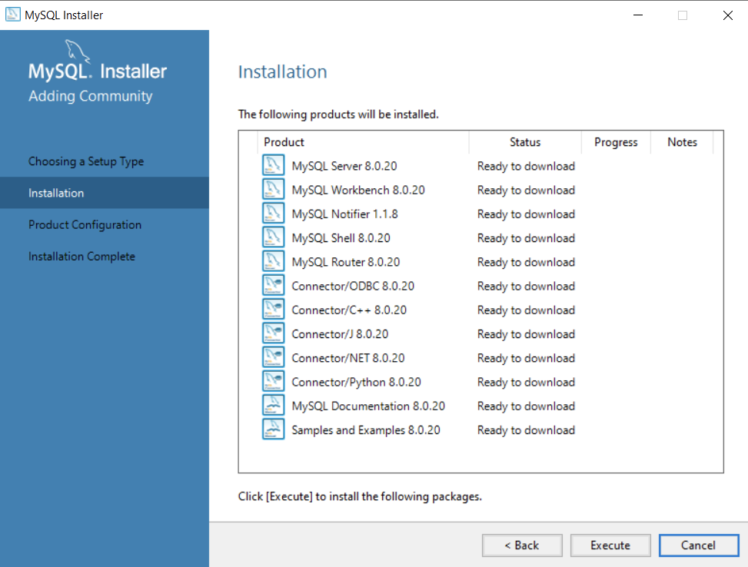

Make sure **MySQL Server, MySQL Workbench and MySQL** **shell** are installed. If there is an error click on try again

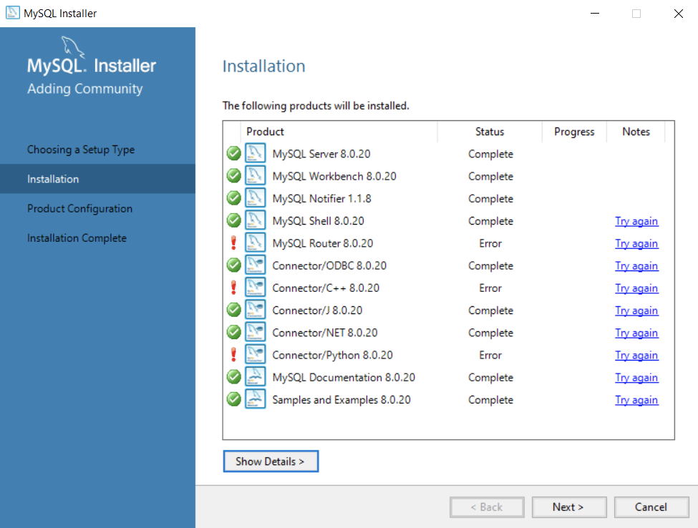

6. Create a password for your root user. **Make sure that you note this password** as you will be referring to it again and again whenever you connect to the database. After that click on **Next.**

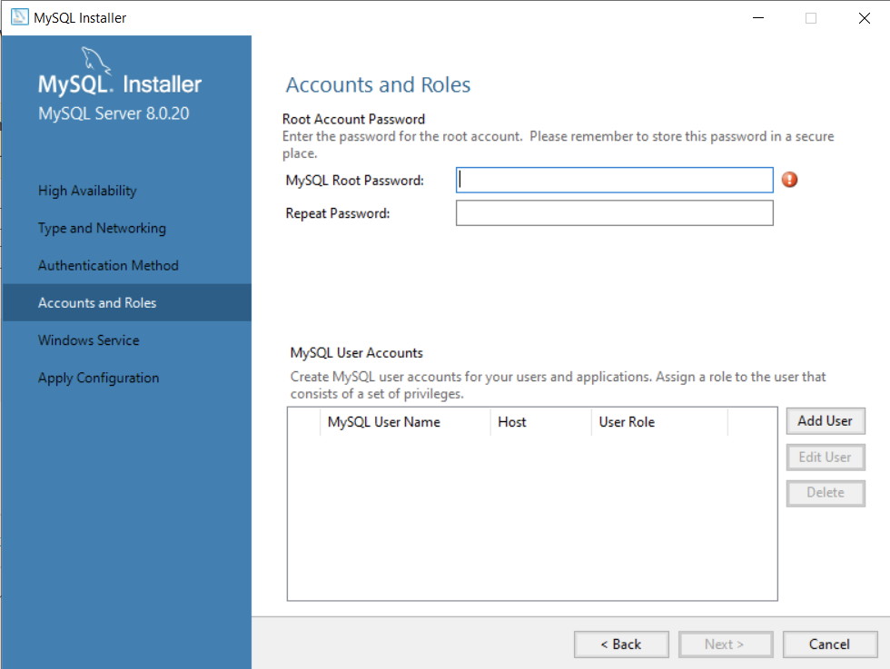

Click on **Execute** and then **Finish**

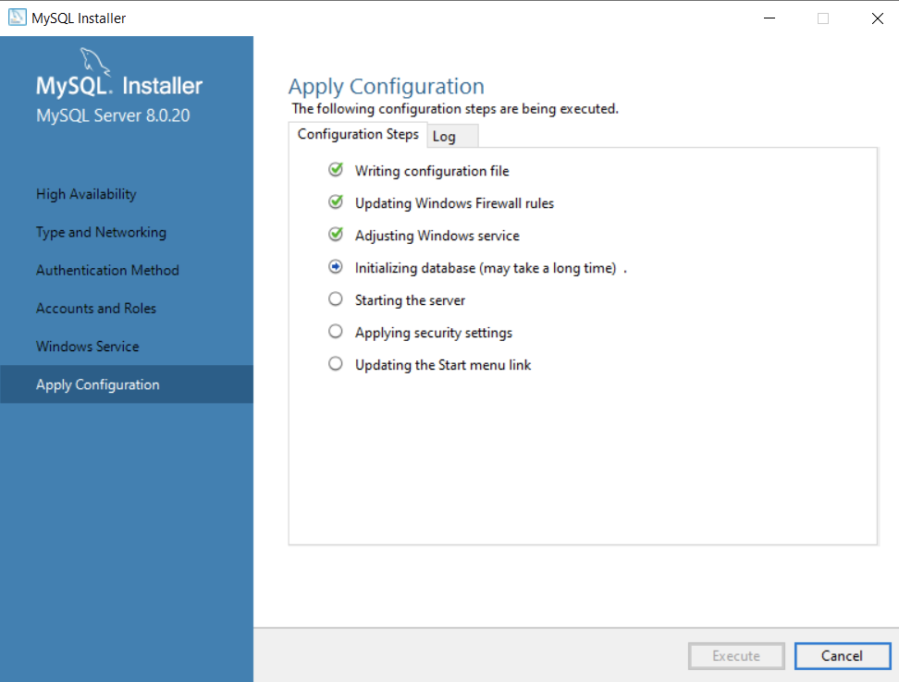

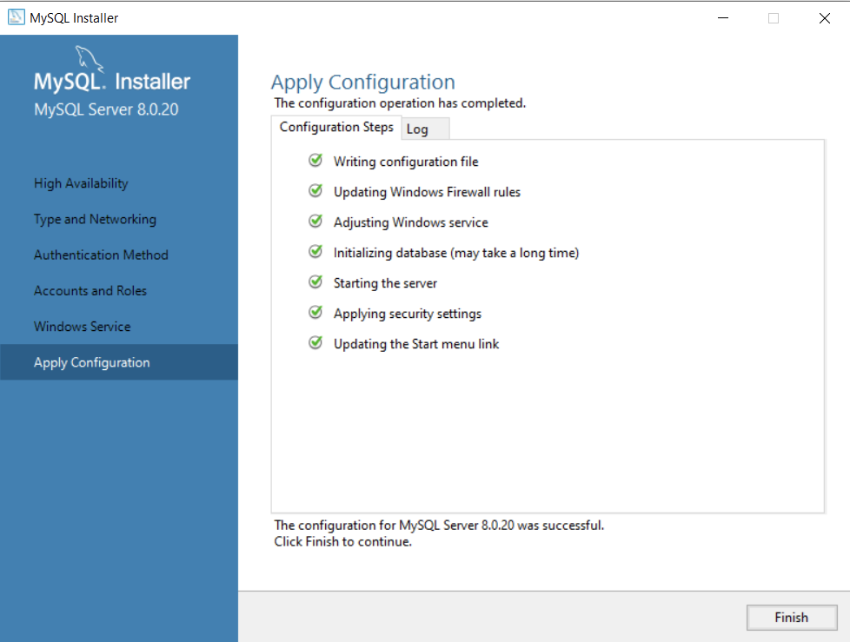

In order to test the connection, it’ll prompt you to enter the password. Do that and click on **Check**.

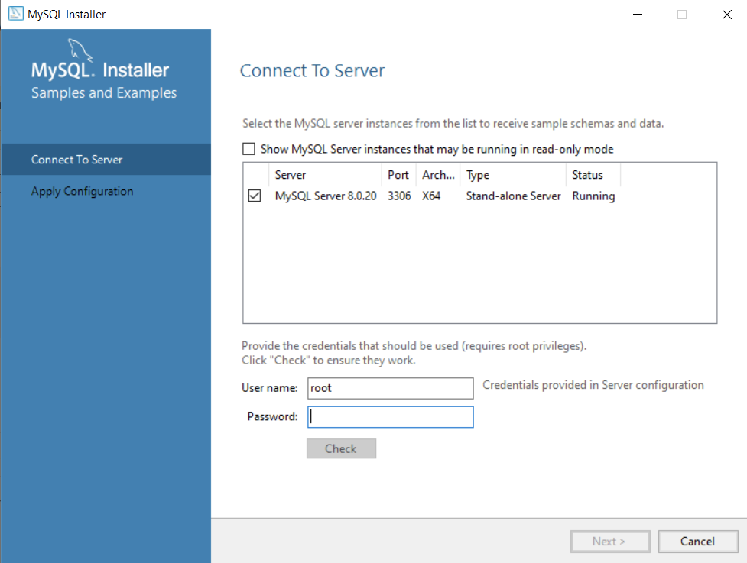

If you enter it right, it should say **Connection succeeded**

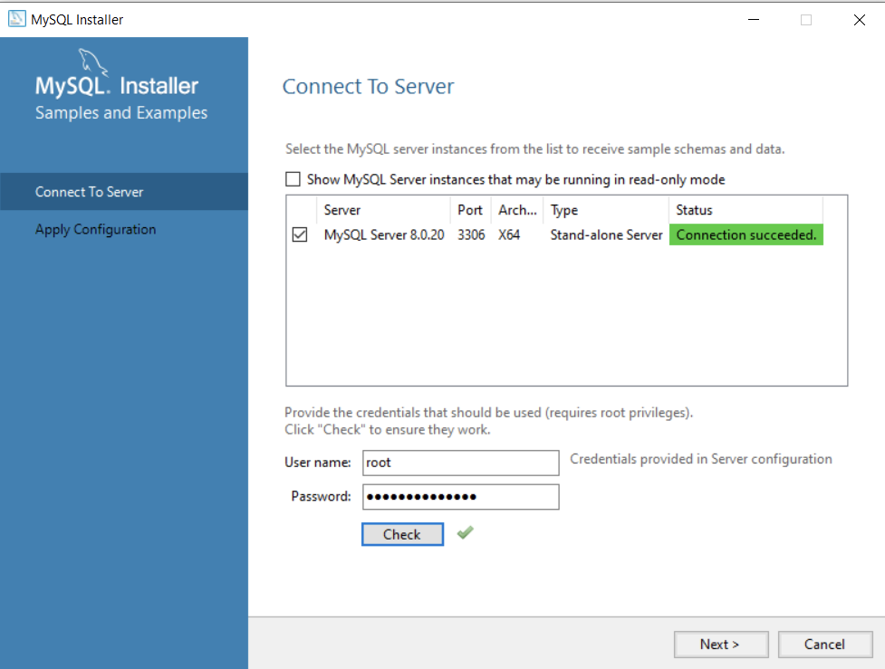

Finally click on **Finish**

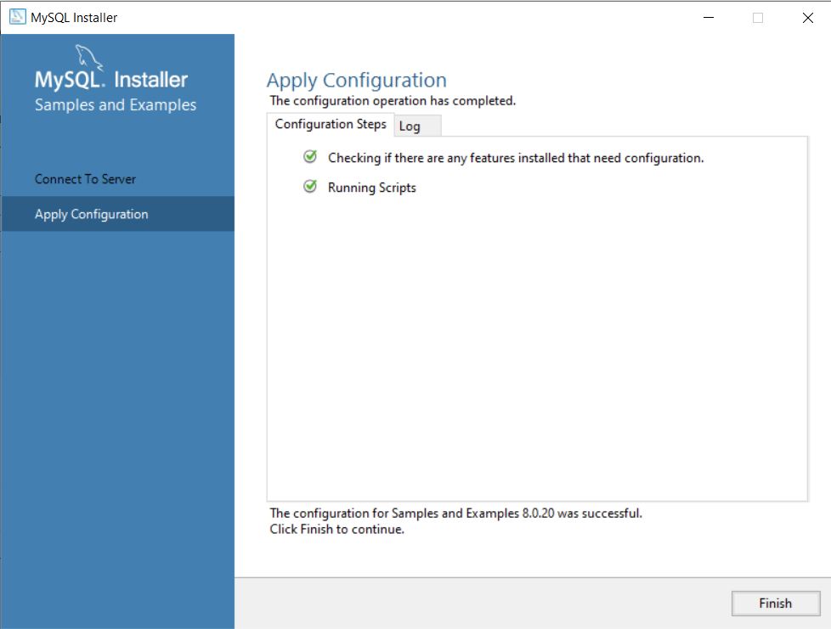

To check that everything is running properly, search for My SQL workbench on your system and open it. The application should look like this:

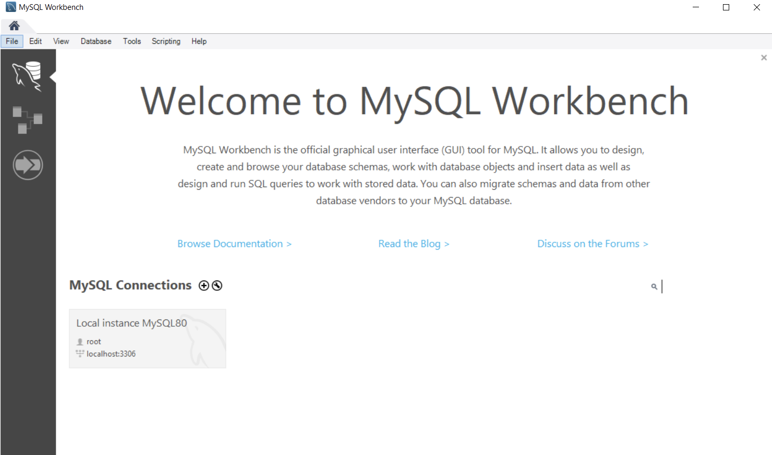

Enter the password to connect to the root user:

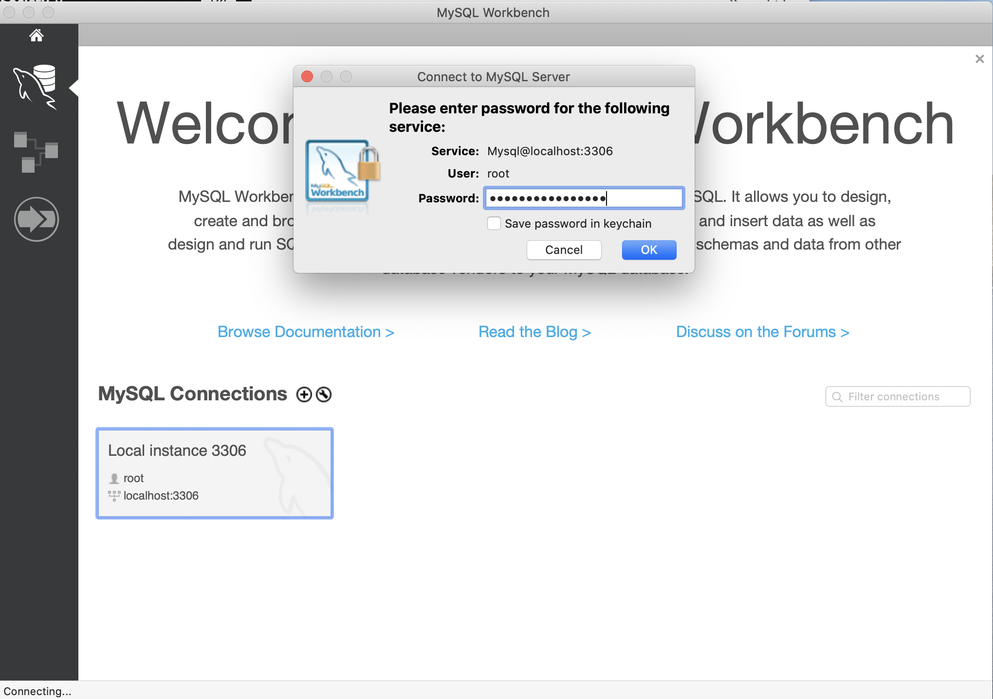

You are now ready to write your SQL queries

